Group Project — Part 1: Exploring the SLCM 0-5 Population Data
Groups of 2 | Presentation: October 1, 2026
Graydon Laughlin, glaughlin1@bellarmine.edu | Tudor Iordan, tiordan2@bellarmine.edu
ABSTRACT

This phase analyzed SLCM’s 0–5 population using intake-ticket data and household-member data. The dataset includes information on housing and eviction status, employment and income, household size, children, ages, and geographic location. One of the strongest patterns was that employment status alone did not fully explain financial hardship. Employed households generally had higher incomes, but some still reported very low income and relied on support such as TANF/SNAP. The analysis also showed that many households include young children and that about 28% of profile-level tickets showed active eviction risk. An important question that remains unanswered is whether SLCM’s services lead to long-term improvements in housing and financial stability. The current data does not consistently track outcomes or follow-up results over time.

I. Introduction
This is Part 1 of a semester-long group project on SLCM's 0-5 population data, worked in teams of two. This phase is exploratory analysis (EDA) — before any modeling, your job is to understand the data well enough to explain it to someone who has never seen it, and to see how it lines up with how the partner organization actually thinks about its own work.
No personal or identifying client information is included in these files. Names, exact birthdates, street addresses, and direct contact information have already been removed or replaced with anonymous IDs before you received this data. Treat it as you would any real client information regardless — do not attempt to re-identify anyone, and do not share it outside this class.

II. Background

A. Data Set Description
Source: South Louisville Community Ministry (SLCM), a Louisville-based nonprofit. This is real, de-identified case data from their intake and case-management system (originally exported from Jira), covering families with children ages 0-5 who came to SLCM for help.
File | Grain (1 row =) | Size
cleaned_intakes_masked.csv | one intake ticket (a family's visit/case) | 639 rows x 93 columns
household_members_long_v2.csv | one additional household member linked to a ticket | 993 rows x 8 columns
Utility data (LG&E and Louisville Water) is intentionally not part of Part 1. It will be introduced in Part 2 once your team understands this core population well; if your team finishes early, ask your instructor about optional bonus scope.
A person can appear more than once. SLCM's system tracks tickets, not people — the same family can have multiple case records over time. A field called PID has already been built for you to identify the same person across multiple tickets; treat it as a given key, but note in your report that it is based on name-matching and is not perfectly reliable.

B. Partner Plan
SLCM staff sketched their own program model on a whiteboard: cases move through three stages — Reconnect (immediate intake), Rethink (3-6 month programs), and Rebuild (policy and long-term stability) — and are informally sorted by how urgent and how recurring their need is. The two diagrams below are deliberately left blank. Filling them in with real numbers from the data is your team's first task (Task 1).
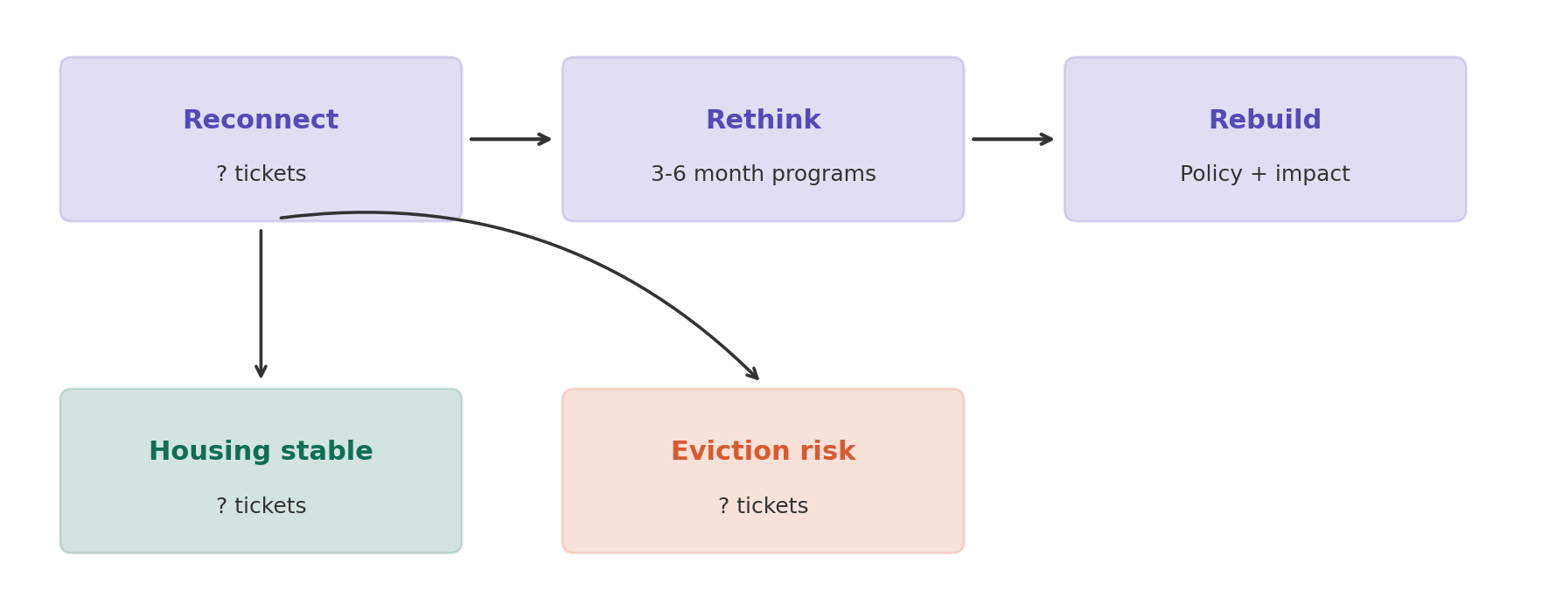
Figure 1. The Reconnect / Rethink / Rebuild stages. Fill in the ticket counts, including the Reconnect-stage split between housing-stable and eviction-risk tickets.
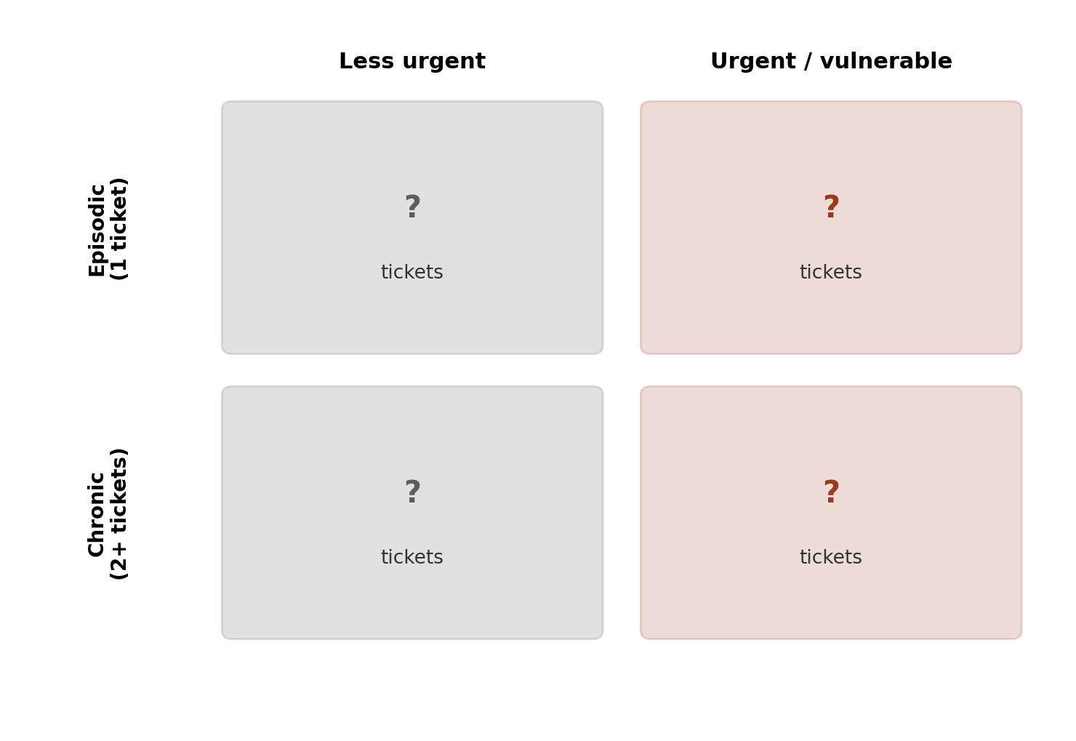
Figure 2. SLCM's urgency/duration segmentation. Fill in each quadrant's ticket count using PID (1 ticket = episodic, 2+ = chronic) and eviction/housing status (currently being evicted or unhoused = urgent). Note in your report that these are proxies SLCM does not record directly — decide for yourselves whether they're reasonable stand-ins.

III. Your Team's Work
Use pandas, matplotlib, and seaborn (and AI assistance where useful) to explore, clean, and understand the data. Your goal for Part 1 is not to build a model — it is to know this dataset better than anyone else in the room, and to know exactly where it does and doesn't support SLCM's own model of their work.

Task 0 — Where did this data come from?
Before analyzing anything, explain in your own words: what does the NEIG-##### ticket number actually represent? Why are ticket numbers not sequential per family? What does Issue Type tell you about which rows are new intakes versus sub-tickets tied to an existing case? A hint, not the answer: look at how ticket number relates to Created date and to Issue id.
What does the NEIG-##### ticket number actually represent?
- NEIG-##### is the unique Jira ticket number assigned to an individual case record.
- It identifies a ticket, not a person, family, or household.
- The data shows that higher NEIG numbers generally correspond to tickets created later in time. For example, older records have numbers around NEIG-10695, while more recent records have numbers around NEIG-19349.
- Issue id also increases as newer tickets are created.
Why are ticket numbers not sequential per family?
- A single person/family, identified by PID, can have multiple tickets over time.
- Ticket numbers are assigned across the entire SLCM Jira system rather than separately for each family.
- Because tickets for many different families are created between a person’s visits, tickets belonging to the same PID are usually not consecutive.
- For example, PID P0101 appears on tickets such as NEIG-12683, NEIG-13006, NEIG-13824, NEIG-14015, NEIG-14662, and NEIG-16993.
What does Issue Type tell you about which rows are new intakes versus sub-tickets tied to an existing case?

Issue Type identifies the type of record represented by each ticket.

The dataset contains 426 profile-level records:

378 New Profile

44 Connected Neighbor Profile

4 Flourishing Neighbor Profile

None of these profile records have a Parent key.

The remaining 213 records are service or care-path tickets, such as:

Rent Assistance Care Path

House Navigation Care Path

Utility Care Path

Legal Assistance Care Path

Basic Supplies

These service/care-path records have a Parent key, which links them back to a profile-level ticket.

Therefore, Issue Type and Parent key should be used together to distinguish profile records from follow-up or service sub-tickets.

The intake dataset is organized around tickets rather than unique people. Issue key identifies the individual ticket, while PID links multiple tickets belonging to the same person/family. Understanding this structure is important because later analyses need to distinguish between profile records, service tickets, unique PIDs, and repeat contacts.

Task 1 — Map the data to the partner plan
- Fill in Figures 1 and 2 above using the real data — show your work (the code and the numbers), not just the final diagram.
Figure 1
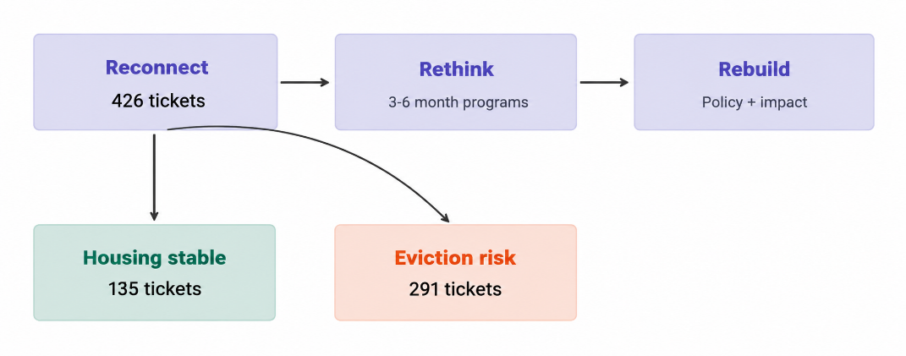
- Reconnect: Counted all profile-level tickets (New Profile, Connected Neighbor Profile, and Flourishing Neighbor Profile). This gave 426 Reconnect tickets.
- Housing stable: From those 426 Reconnect tickets, records were classified as stable when their housing and eviction fields did not indicate housing risk. This included Rent - nothing past due, Own home - nothing past due, and the Other records that were explicitly marked Not being evicted. This gave 135 tickets.
- Eviction risk: From those same 426 Reconnect tickets, a record was classified as at risk if Housing Status showed past-due rent/mortgage, staying with friends/family, unhoused, or short-term housing, or if Eviction Status was Currently being evicted or Received 7 day notice. This gave 291 tickets.
Figure 2
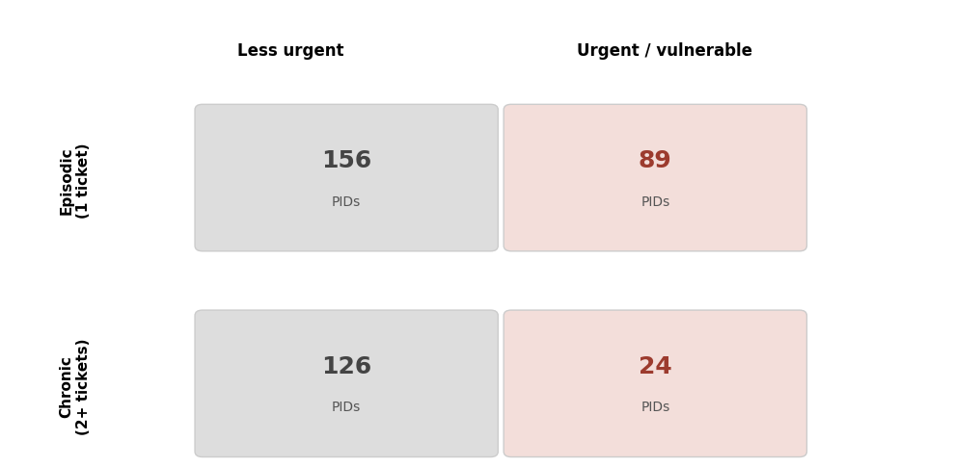
- We used PID to group people by how often they appeared in the dataset. A PID with exactly 1 ticket was classified as Episodic, while a PID with 2 or more tickets was classified as Chronic. This follows the definition provided for Figure 2.
- To determine urgency, we used each PID's most recent profile-level record and examined Custom field (Housing Status) and Custom field (Eviction Status). A PID was classified as Urgent / vulnerable when the most recent record showed Unhoused or Currently being evicted. All other PIDs were classified as Less urgent.
- The final groups were:
  - Episodic + Less urgent: 156 PIDs
  - Episodic + Urgent / vulnerable: 89 PIDs
  - Chronic + Less urgent: 126 PIDs
  - Chronic + Urgent / vulnerable: 24 PIDs
- In total, Figure 2 includes 395 PIDs with profile-level records.

- Build a column triage table: go through all 93 columns in cleaned_intakes_masked.csv and classify each as Needed, Optional, or Drop for this phase, with a one-line reason for each. Many columns are Jira system fields (staff names, internal IDs, board sort order) rather than case data — part of the exercise is telling those apart from columns that actually describe a family's situation.

Column | Classification | Reason
PID | Needed | Identifies the same person/family across multiple tickets and is required for repeat-contact analysis.
PID Match Basis | Optional | Helps evaluate how reliably records were matched to the same PID.
Summary | Drop | Mostly descriptive ticket text and is not required for the quantitative analysis.
Issue key | Needed | Identifies each individual Jira ticket and supports ticket and parent-ticket analysis.
Issue id | Drop | Internal Jira identifier; Issue key already identifies the ticket.
Issue Type | Needed | Distinguishes profile-level tickets from service/care-path sub-tickets.
Status | Drop | Jira workflow status rather than information about the household's situation.
Resolution | Drop | Jira workflow outcome that is not required for the main analysis.
Reporter | Drop | Identifies staff rather than describing the household.
Reporter Id | Drop | Internal staff identifier.
Creator | Drop | Identifies the staff member who created the ticket rather than the household.
Creator Id | Drop | Internal staff identifier.
Created | Needed | Required to order tickets over time and identify first and most recent contacts.
Updated | Optional | Shows when the ticket was last modified and could help examine how long cases remain active.
Resolved | Optional | Shows when a ticket was resolved and could support analysis of case duration.
Labels.1 | Drop | Jira tagging field that is not needed for the required analysis.
Labels.2 | Drop | Jira tagging field that is not needed for the required analysis.
Labels.3 | Drop | Jira tagging field that is not needed for the required analysis.
Labels.4 | Drop | Jira tagging field that is not needed for the required analysis.
Labels.5 | Drop | Jira tagging field that is not needed for the required analysis.
Labels.6 | Drop | Jira tagging field that is not needed for the required analysis.
Watchers | Drop | Staff/workflow information rather than household information.
Watchers.1 | Drop | Additional staff/workflow information that is not needed.
Watchers Id | Drop | Internal Jira identifier.
Watchers Id.1 | Drop | Internal Jira identifier.
# Additional Household Members | Needed | Directly supports household-size and household-composition analysis.
Custom field (City) | Optional | Provides additional geographic context and can be compared with ZIP Code.
Custom field (Community Ministry) | Optional | Could be used to compare cases across different community ministry service areas.
Custom field (Court Date) | Optional | Could provide additional information about the severity and timing of eviction cases.
Custom field (Current Employer) | Drop | Employer name is not necessary; Employment Status is sufficient for the main analysis.
Age at Intake | Needed | Core demographic variable for describing the population served.
Custom field (Employment Status) | Needed | Directly required for the employment-versus-income analysis.
Custom field (Eviction Reason) | Needed | Helps explain why households are experiencing eviction or housing instability.
Custom field (Eviction Status) | Needed | Required for Figures 1–2 and the housing-crisis analysis.
Custom field (Gender) | Needed | Core demographic variable for describing the population.
Custom field (Goals) | Drop | Qualitative goal information that is not required for the main quantitative analysis.
Custom field (Goals).1 | Drop | Additional qualitative goal information that is not required.
Custom field (Goals).2 | Drop | Additional qualitative goal information that is not required.
Custom field (Goals).3 | Drop | Additional qualitative goal information that is not required.
Custom field (Household Identities) | Optional | May provide useful demographic or household context but is not central to the required questions.
Custom field (Household Identities).1 | Optional | Provides additional household-identity information that may support descriptive analysis.
Custom field (Household repairs required?) | Optional | Could provide useful information about housing quality and instability.
Custom field (Housing Status) | Needed | Central variable for housing stability, urgency, and Figures 1–2.
Custom field (Income Amount ($)) | Needed | Directly required for the employment-versus-income analysis.
Custom field (Insurance Provider for Family) | Optional | Could be simplified into insured versus uninsured and used to examine healthcare coverage.
Custom field (Intake Date) | Optional | Can be compared with Created, although Created is sufficient for the main time-based analysis.
Has LG&E Account on File | Drop | Administrative utility-account information rather than a direct measure of hardship.
Custom field (Landlord Name) | Drop | Specific landlord information is not needed for population-level analysis.
Custom field (Loss of Income Causation) | Optional | Could help explain why households experienced reduced income or financial hardship.
Custom field (Loss of Income Causation).1 | Optional | Captures an additional reason for loss of income when more than one cause is recorded.
Custom field (Loss of Income Causation).2 | Optional | Provides additional information about causes of income loss.
Custom field (Loss of Income Causation).3 | Optional | Provides additional information about causes of income loss.
Custom field (Main reason Neighbor stopped paying rent) | Needed | Helps explain the causes behind rent delinquency and housing instability.
Custom field (Monthly Rent ($)) | Needed | Important measure of housing cost and useful for analyzing housing burden.
Has Email on File | Drop | Contact-administration information that is not relevant to the required EDA.
Has Phone on File | Drop | Contact-administration information that is not relevant to the required EDA.
Custom field (Other Professionals Detail) | Drop | Unstructured case information that is not required for the main analysis.
Custom field (Other professionals helping with goals?) | Drop | Support-network information that is not required for the five main questions.
Custom field (Past Due Rent ($)) | Needed | Measures the severity of rent and housing hardship.
Custom field (People in Household 17 and Under) | Needed | Required for understanding children and household composition.
Custom field (People in Household 18+) | Needed | Required for understanding adult household composition and household size.
Custom field (People in Household 65+) | Needed | Adds important demographic information about household composition.
Custom field (Preferred method of contact) | Drop | Contact preference is not relevant to the main population analysis.
Custom field (Preferred method of contact).1 | Drop | Additional contact preference information that is not required.
Custom field (Primary Insurance) | Drop | Duplicates insurance-related information and is not required for the main analysis.
Custom field (Primary Language Spoken in Home) | Needed | Relevant demographic and access characteristic of the households served.
Custom field (Pronoun) | Optional | Provides additional demographic information but is not central to the required analysis.
Custom field (Race/Ethnicity) | Needed | Core demographic variable for describing the population served.
Custom field (Rank) | Drop | Jira board-ordering field rather than household information.
Custom field (Rent Intake Form Goals) | Drop | Qualitative rental-assistance goal information that is not needed for the main quantitative analysis.
Custom field (Rent Intake Form Goals).1 | Drop | Additional rental-goal information that is not required.
Custom field (Rent Intake Form Goals).2 | Drop | Additional rental-goal information that is not required.
Custom field (Rent Intake Form Goals).3 | Drop | Additional rental-goal information that is not required.
Custom field (Rent-to-Income %) | Needed | Direct measure of housing affordability and financial burden.
Custom field (Response Method) | Drop | Program/workflow information rather than household-condition information.
Custom field (Response Method).1 | Drop | Additional program/workflow information that is not needed.
Custom field (Section 8 or Housing Voucher) | Needed | Relevant housing-support variable that may relate to housing stability and affordability.
Custom field (Source of income) | Needed | Directly required for the employment-versus-income analysis.
Custom field (Source of income).1 | Needed | Captures additional income sources and should be considered with the primary source.
Custom field (State) | Optional | Provides broader geographic information and can help validate or supplement City and ZIP Code.
Custom field (Utility Past Due) | Optional | Could provide additional evidence of financial hardship beyond rent.
Has Water Account on File | Drop | Administrative utility-account information rather than a direct measure of hardship.
Custom field (Zip Code) | Needed | Explicitly required for comparing housing crisis severity across ZIP codes.
Custom field ([CHART] Date of First Response) | Drop | Jira response-time metric that is not relevant to the required population analysis.
Custom field ([CHART] Time in Status) | Drop | Jira workflow metric rather than household information.
Comment | Drop | Unstructured text that is not required for the main quantitative analysis.
Comment.1 | Drop | Additional unstructured text that is not required.
Comment.2 | Drop | Additional unstructured text that is not required.
Parent | Drop | Parent key already provides the parent-ticket relationship more directly.
Parent key | Needed | Required to identify service/care-path tickets linked to parent profile tickets.
Parent summary | Drop | Duplicates information about the parent ticket and is not required once Parent key is retained.
Status Category | Drop | Jira workflow grouping rather than household-condition information.
Status Category Changed | Drop | Jira workflow information that is not needed for the main EDA.

- Identify, in writing, which parts of the partner's plan the data does NOT currently support (for example: is there a field that captures the Rethink or Rebuild stage? If not, what would you propose SLCM start collecting?).
The current dataset supports some parts of SLCM’s partner model, but several elements cannot be identified directly from the available fields.
Reconnect:
Reconnect is not directly recorded as a field. We used profile-level tickets (New Profile, Connected Neighbor Profile, and Flourishing Neighbor Profile) as a proxy for the Reconnect stage because this stage represents immediate intake.
Rethink:
The dataset does not contain a field that identifies whether a household entered the Rethink stage or participated in a 3–6 month program. There is also no standardized information showing the type of Rethink program, when it started, or whether it was completed.
Rebuild:
The dataset does not contain a field showing whether a household reached the Rebuild stage or achieved long-term stability. There is also no clear long-term outcome field showing whether housing, income, employment, or overall stability improved after receiving services.
Urgency:
Urgency is not directly recorded. For Figure 2, we created a proxy using Custom field (Housing Status) and Custom field (Eviction Status). A PID was considered urgent when the most recent profile showed Unhoused or Currently being evicted.
Episodic vs. Chronic Need:
The dataset does not directly classify households as episodic or chronic. We used the number of tickets associated with each PID as a proxy, where 1 ticket was considered episodic and 2 or more tickets were considered chronic.
Movement Between Stages:
The dataset does not clearly show when a household moves from Reconnect to Rethink or from Rethink to Rebuild. Because stage transitions are not directly recorded, it is difficult to track a household’s progress through the partner model.
Long-Term Outcomes:
The data mainly describes households at intake and during service contacts. It does not consistently record follow-up outcomes several months later, so long-term improvement cannot be measured directly.
PID Limitation:
PID is useful for linking repeat contacts, but it is based on name matching and is not perfectly reliable. This limits how confidently long-term histories can be reconstructed.
Recommended Fields for SLCM to Collect
To better support the Reconnect–Rethink–Rebuild model, SLCM could begin collecting standardized fields such as:
- Program Stage: Reconnect, Rethink, or Rebuild
- Stage Entry Date
- Stage Exit Date
- Rethink Program Type
- Urgency Level
- Reason for Stage Transition
- Program Completion Status
- Housing Status at Follow-up
- Employment Status at Follow-up
- Income at Follow-up
- 3-Month Follow-up Outcome
- 6-Month Follow-up Outcome
- 12-Month Follow-up Outcome
- Long-Term Stability Outcome
Collecting these fields would allow SLCM to measure how households move through the program model and whether their situations improve over time, rather than relying on proxies created from existing fields.

Task 2 — Explore, clean, and answer
- Summarize both files: row/column counts, data types, a data dictionary built from your Task 1 triage.
- Intake Data Frame
  - Rows: 639
  - Columns: 93
  - Purpose: Contains information about SLCM intakes/tickets and the families connected to those tickets.
  - Main types of information:
    - PID and ticket information
    - Issue Type and case status
    - Created, Updated, Resolved, Intake Date, and Court Date
    - Housing and eviction status
    - Employment status and income
    - Monthly rent and past-due rent
    - Household size and age groups
    - Demographic information
    - Geographic information such as city, state, and ZIP code
  - Data types:
    - Object/string: Most categorical and identifying fields, such as PID, Issue Type, Housing Status, Employment Status, and ZIP Code.
    - Numeric: Variables such as Age at Intake, Income Amount, Monthly Rent, Past Due Rent, and household counts.
    - Datetime: Date fields such as Created, Updated, Resolved, Intake Date, and Court Date after cleaning.
  - Data dictionary: The columns were classified through the Task 1 triage as Needed, Optional, or Drop based on whether they support the family's situation and the required analysis.
- Household Data Frame
  - Rows: 993
  - Columns: 8
  - Purpose: Contains information about individual members within the households connected to the intake data.
  - Columns include:
    - PID
    - Member ID
    - Issue key
    - Member #
    - Age
    - Gender
    - Race/Ethnicity
    - Relationship
  - Data types:
    - Object/string: PID, Member ID, Issue key, Gender, Race/Ethnicity, and Relationship.
    - Numeric: Member # and Age.
  - Main use: Supports analysis of household size, household composition, ages, children, and relationships between household members.
  - Data quality note: The household Age field contains some incorrect values, which should be documented as a data-quality issue rather than automatically removed
- Explore each variable you kept. Focus on the ones that look unusual — skewed distributions, unexpected missingness, outliers, or values that don't make sense.
- Intake Data Frame
  - Age at Intake

    - Has missing values.
    - The minimum value is -1, which is not a valid age.
    - The maximum value is 71.
    - The negative value should be investigated and documented as a data-quality issue.
  - Income Amount ($)
    - Has missing values.
    - The distribution is skewed because most reported incomes are lower, while some households report substantially higher amounts.
    - The maximum reported income is $75,000.
    - Missing income should not automatically be treated as zero.
  - Monthly Rent ($)
    - Contains some unusually large values.
    - The maximum reported monthly rent is approximately $125,100, which appears unusual for a monthly rent amount and should be investigated.
    - Missing values are also present.
  - Past Due Rent ($)
    - Contains very large values.
    - The maximum reported past-due rent is approximately $242,682, which appears unusual and should be investigated for possible data-entry or unit errors.
    - Missing values are also present.
  - Housing Status
    - Has a substantial amount of missing information.
    - The observed categories include Currently being evicted, Unhoused, not being evicted, Rent - nothing past due, and Own home - nothing past due.
    - The missing values are important because housing status is a major variable for the housing analysis.
  - Eviction Status
    - Contains missing values.
    - The variable is important for identifying households experiencing eviction risk.
    - Different eviction-related responses should be checked for consistency.
  - Employment Status
    - Contains missing values.
    - The categories should be reviewed to make sure employment statuses are consistently recorded.
    - Missing employment information limits how accurately employment can be summarized.
  - Household Size Variables
    - Variables such as # Additional Household Members, People in Household 17 and Under, People in Household 18+, and People in Household 65+ should be checked for unusual or inconsistent values.
    - These variables are important for understanding household composition.
  - ZIP Code
    - ZIP codes are not consistently formatted.
    - Some values appear as five-digit ZIP codes while others include the additional four-digit extension, such as 40214-5715.
    - This should be standardized.
- Household Data Frame
  - Age
    - This is the most obvious data-quality problem in the household file.
    - Ages range from -35 to 1,824, which includes values that are clearly impossible for a person's age.
    - These values should be flagged and documented rather than automatically deleted.
  - Gender
    - Should be checked for missing values and inconsistent category labels.
    - Missing or inconsistent responses could affect demographic summaries.
  - Race/Ethnicity
    - Should be checked for missing values and inconsistent category labels.
    - Missing information should be reported rather than assuming a race/ethnicity category.
  - Relationship
    - Should be reviewed for missing or unusual relationship categories.
    - This variable is important for understanding household composition.
  - Member #
    - Should generally represent the member's position within the household.
    - Unusual or duplicate member numbers should be checked for possible data-entry issues.
- Clean what needs cleaning, and document every decision. Don't silently fix things.
Before beginning the analysis, the intake data was reviewed for formatting problems, invalid values, and possible data-entry errors. The original variables were preserved whenever possible, and cleaned versions were created when changes were necessary. Missing or suspicious values were not estimated unless the data provided enough evidence to determine the correct value.
ZIP Code. ZIP codes were standardized to a five-digit format so that ZIP+4 entries would not be treated as separate geographic areas. A cleaned variable, Zip Code Clean, was created while preserving the original ZIP Code field. Leading and trailing spaces were removed, and only the first five characters were retained for ZIP+4 values. One invalid ZIP code, 402q1, contained a letter. Because there was not enough evidence to determine the intended digit, this value was treated as missing rather than being guessed. Existing missing ZIP codes were also left as missing.
City and State. Cleaned City and State variables were created to correct obvious spelling and formatting inconsistencies. Variations such as Louisville Ky, Lousville, Louisvile, Louisvill, and Louisvlle were standardized to Louisville. Shivley was corrected to Shively. Legitimate locations such as Fairdale, Prospect, and Boston were kept as separate categories. In the State field, KENTUCKY and KY referred to the same state, so all Kentucky records were standardized to KY. Missing City and State values were not estimated.
Monthly Rent and Past Due Rent. The monetary variables were examined for unusually large values. Monthly Rent contained a value of $125,100, and Past Due Rent contained a value of $242,682. These values were considered clear data-entry errors and were replaced with missing values (NaN) rather than attempting to guess the intended amounts. The rest of the record was preserved. After these corrections, the highest Monthly Rent was $3,743.94 and the highest Past Due Rent was $16,000. Although these values were high, they were still considered possible and were retained.
Income Amount. The Income Amount field also contained unusually large values. The Rent-to-Income percentage was used to understand how income was recorded. For records with complete information, the reported percentage matched the calculation:
Monthly Rent ÷ Income Amount × 100
This provided evidence that Income Amount was generally being treated as a monthly value. However, six records contained income amounts between $24,000 and $75,000, which were inconsistent with the scale of the rest of the monthly income data. One strong example was PID P0025, whose income changed from $1,500 to $30,000 within a few weeks while the employment category remained part-time employment. Because it was not possible to determine whether these large values represented annual income, misplaced digits, or another entry error, they were not converted or estimated. A cleaned income variable was created, and values greater than $10,000 were treated as missing for numerical income analysis. The original values were preserved in the source variable. Income values of $0 were kept because zero can represent a household with no reported income.
Household Composition Variables. The variables for household members age 17 and under, age 18+, and age 65+ were reviewed. The first two contained categories from 0 through 5 and More than 5, while the 65+ variable was recorded as Yes or No. These variables were left unchanged because converting More than 5 into a specific number would require an unsupported assumption. Similarly, the 65+ field indicates only whether a person age 65 or older is present and does not provide an exact count. The original categorical information was therefore preserved.
- Plot what you find — anything that reveals something real about this population.
- Answer the five questions below. For each: state your answer, show the analysis/plot that supports it, and note any caveats.

The Five Questions
- Housing crisis severity: what share of tickets show active eviction risk (currently being evicted, or unhoused) versus stable housing? Does this differ by zip code or by household size?
A profile-level ticket was considered to show active eviction risk when the household was either currently being evicted or unhoused. Of the 426 profile-level intake tickets, 120 (28.17%) met this definition, while 306 (71.83%) did not. Therefore, slightly more than one-quarter of the profile-level tickets represented households facing the most immediate forms of housing instability defined in this project.
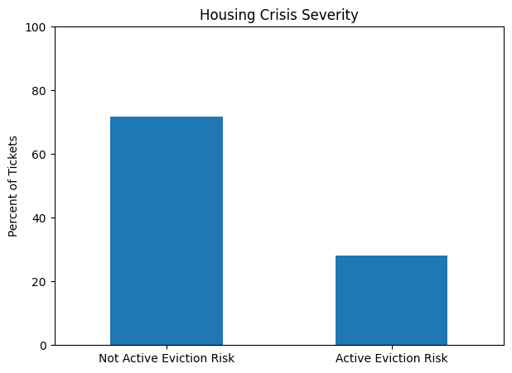
Active eviction risk varied considerably by ZIP code. Among ZIP codes with at least five tickets, some of the highest rates occurred in 40272 (75.00%), 40202 (71.43%), and 40206 (66.67%). In contrast, lower rates were observed in ZIP codes such as 40208 (11.11%), 40215 (13.48%), and 40217 (14.29%). This suggests that the level of active eviction risk differs geographically within the population represented in the data. However, some ZIP codes had relatively few observations, so unusually high percentages in smaller groups should be interpreted cautiously.
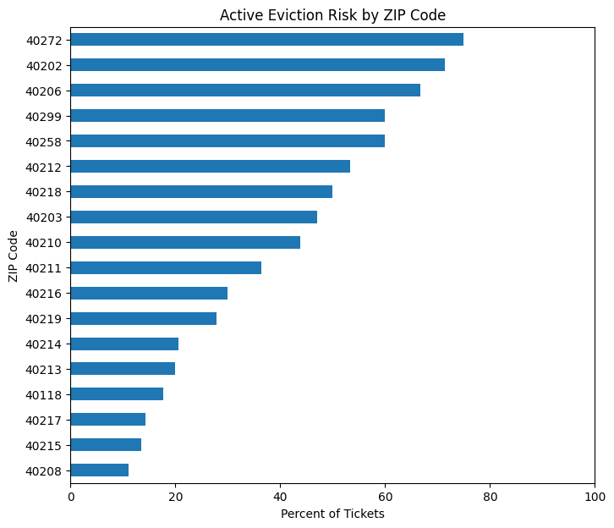
Household size also showed differences in active eviction risk, but there was no clear increasing or decreasing pattern. For example, households of size 1 had a rate of 19.23%, households of size 3 had a rate of 30.59%, and households of size 5 had a rate of 36.96%. Household size 7 had the highest observed rate at 60.00%, but this represented only five tickets. Therefore, the household-size results show variation, but they do not support a simple conclusion that larger households consistently experience greater active eviction risk.
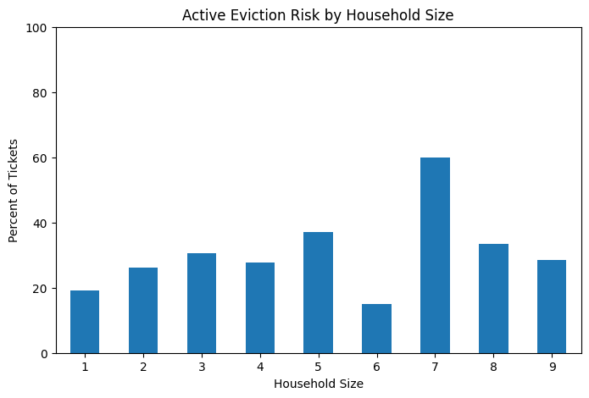
An important limitation is that the category Not Active Eviction Risk does not necessarily mean that a household was completely housing stable. Some households may still have past-due rent, be staying with friends or family, or experience other housing difficulties without being currently evicted or unhoused.
- Employment vs. income mismatch: employment status alone doesn't predict financial hardship in this data. Show, with a plot, how income amount and source of income vary between employed and unemployed households.
Employment status was simplified into employed and unemployed groups. The employed group included individuals recorded as employed as well as those who were employed but needed more hours or different work. The unemployed group included individuals who wanted to find work and those who were not currently looking for work. Records classified as Other were excluded from this comparison.
Income differed considerably between the groups. Among records with usable cleaned income data, employed households had an average monthly income of approximately $1,976 and a median of $2,000. Unemployed households had an average income of approximately $517 and a median of $0. Although employed households generally had higher incomes, the distributions overlapped. Some employed households reported little or no income, while some unemployed households still reported income.
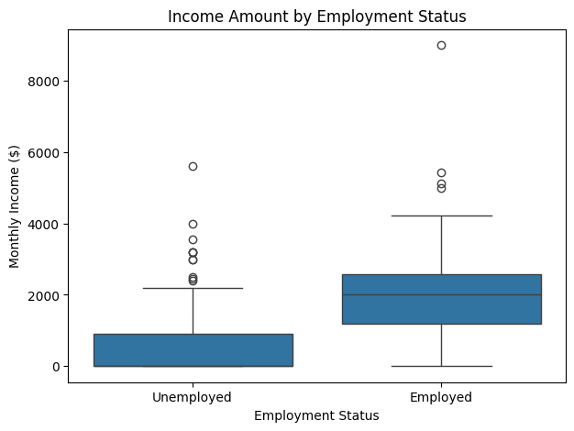
Income sources provide additional evidence that employment status alone does not describe financial hardship. Among reported income sources for employed households, 40.68% were full-time employment, 27.54% were part-time employment, and 22.88% were Food benefits - TANF/SNAP. This indicates that some households continued to rely on public assistance despite being employed.
For unemployed households, the most common reported sources were No income (38.82%), Food benefits - TANF/SNAP (36.51%), and Social Security - SSI/SSDI (10.53%). A small number of unemployed records also listed full-time or part-time employment as an income source. This may reflect changing employment circumstances, multiple household income sources, or inconsistencies between the employment and income-source fields.
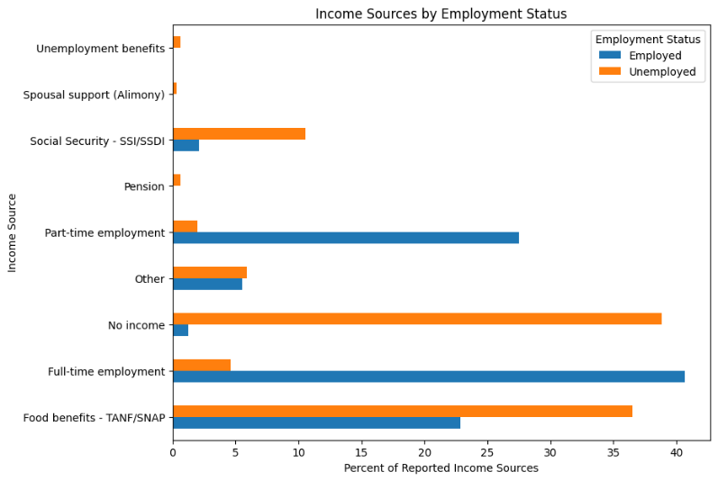

Overall, the results show that employment status alone is not enough to describe financial hardship. Income amount and income source provide important additional information because households within the same employment category can have very different financial situations.
A limitation is that households may report more than one source of income, so income-source percentages represent the distribution of reported sources rather than the percentage of unique households. The analysis also uses profile-level tickets, meaning the same PID may appear more than once.
- Household composition: what does the typical household look like in this data (household size, number of children, ages)? Use household_members_long_v2.csv to describe the additional family members, not just the primary contact.
The household composition analysis used both the intake data and household_members_long_v2.csv. Household size was calculated as the primary contact plus the recorded number of additional household members.
Across the 426 profile-level intake tickets, household size ranged from 1 to 9 people, with an average of 3.33 and a median of 3 people. The most common household size was 2 people. Overall, most households contained approximately two to four people.
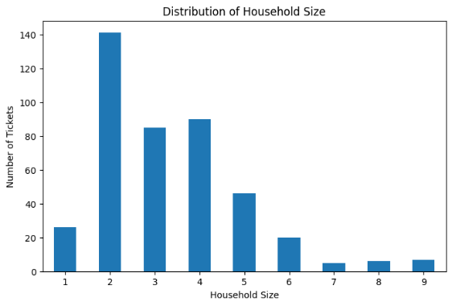
Children were also common in these households. The most frequent response for the number of household members age 17 and under was 2 children, reported by 128 households. This was followed by 1 child in 103 households and 3 children in 98 households. Only 27 households reported no children age 17 or under.
The household-member file provides additional detail about family composition. After clearly invalid ages were treated as missing, 891 additional household members had usable age information. Their average age was 9.37 years, while the median age was only 6 years. Approximately 85.63% of these additional household members were children age 0–17, compared with 14.37% who were adults age 18 or older.
These results show that the typical household represented in the data is relatively small but includes young children. A typical profile has approximately three household members, commonly includes two children, and the additional family members are predominantly children.
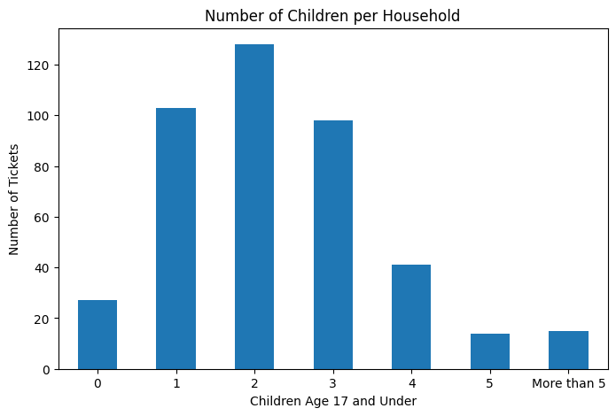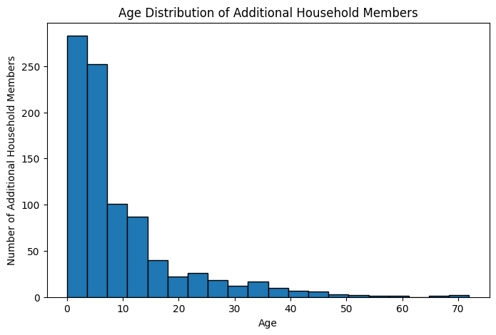
A limitation is that the children variable includes a More than 5 category, meaning an exact average number of children cannot be calculated without making an assumption. In addition, the household-member age analysis describes additional family members only and does not include the primary contact.
- Repeat contact: using PID, how many people appear on more than one ticket? For people with 2+ tickets, does anything change between their first and most recent ticket (housing status, eviction status)?
Repeat contact was measured using PID across all intake tickets. The dataset contained 439 unique PIDs, of which 150 (34.17%) appeared on more than one ticket. The remaining 289 people (65.83%) appeared on only one ticket. Most repeat-contact individuals had two tickets: 109 people had two tickets, 34 had three, six had four, and one person had six tickets.
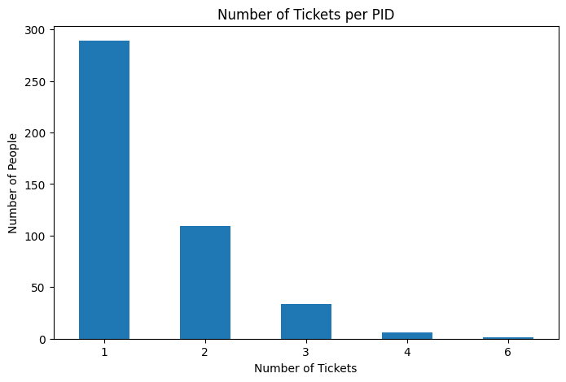
To determine whether housing circumstances changed over time, the analysis compared the first and most recent profile-level records for repeat-contact PIDs. Profile records were used because service and care-path subtickets generally do not contain Housing Status or Eviction Status. Of the 150 repeat-contact PIDs, only 27 had at least two profile-level records that could be compared.
Among these 27 people, 5 (18.52%) experienced a change in Housing Status, while 22 (81.48%) remained in the same housing category. Observed transitions included two people moving from rent with nothing past due to rent past due, one person moving from rent past due to nothing past due, and two people moving from staying with friends or family into rental housing.
Eviction Status changed somewhat more frequently. Eight people (29.63%) had a different Eviction Status on their most recent profile, while 19 (70.37%) remained unchanged. Two people moved from currently being evicted to not being evicted, while one moved in the opposite direction. Five other changes involved records that were initially classified as unknown.

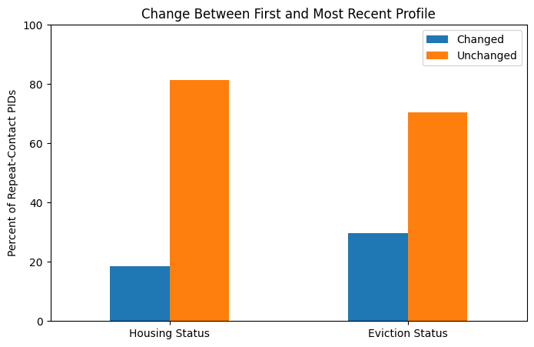
Overall, repeat contact was relatively common, with approximately one-third of PIDs appearing on more than one ticket. However, most repeat-contact individuals with comparable profile records did not show a change in Housing Status or Eviction Status.
A major limitation is that many repeat contacts were service subtickets rather than complete new profiles. Therefore, only 27 of the 150 repeat-contact PIDs had sufficient profile information for a first-versus-most-recent comparison. In addition, a change in category does not necessarily represent improvement or deterioration; some changes may reflect additional information being collected during later contacts.
- Data quality: find and document at least two data quality issues in this dataset. Explain how you would handle each one and why.
Two major data-quality problems were identified during the analysis: invalid household-member ages and incorrect or inconsistent monetary values.
The household-member Age variable contained clearly impossible values, including negative ages and values as high as approximately 1,824. Of the 900 originally recorded ages, 9 were identified as impossible because they were below 0 or above 120. These values were replaced with missing values in a new cleaned age variable rather than being estimated. This left 891 usable ages for analysis. Treating impossible ages as missing prevents them from distorting statistics such as the mean age and the percentage of household members who are children.
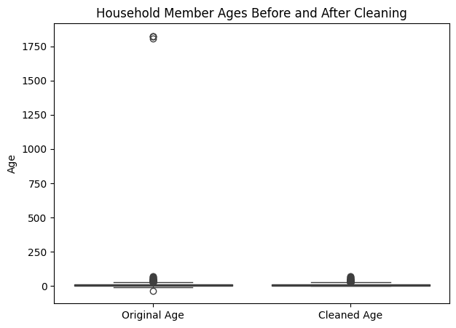
The intake data also contained several clearly incorrect monetary values. Monthly Rent included a value of $125,100, while Past Due Rent included $242,682. These values were treated as data-entry errors and replaced with missing values because there was not enough information to determine their intended values. After cleaning, the maximum Monthly Rent was $3,743.94, while the maximum Past Due Rent was $16,000.
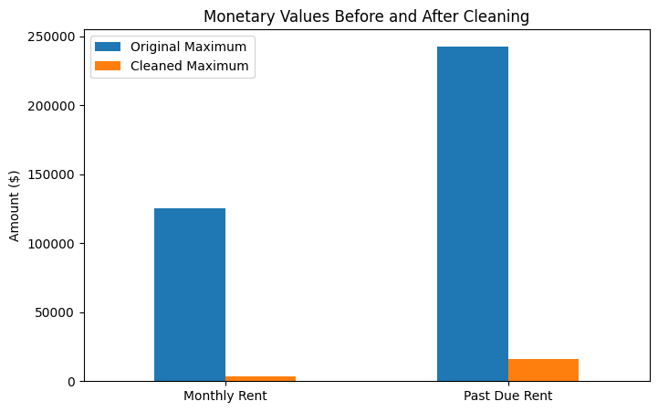
The Income Amount field presented an additional monetary issue. Six values ranged from $24,000 to $75,000, even though comparisons with the Rent-to-Income percentage showed that Income Amount was generally being used as a monthly income measure. These unusually high values were therefore excluded from numerical income analysis using a cleaned income variable. They were not automatically converted to monthly amounts because it was unclear whether they represented annual salaries, misplaced digits, or another entry error.
A smaller but still important quality issue involved geographic information. ZIP codes appeared in both five-digit and ZIP+4 formats, one ZIP contained an invalid letter (402q1), Louisville was entered using several different spellings, and Kentucky appeared as both KY and KENTUCKY. These values were standardized where the intended value was clear.
Overall, the cleaning process followed a conservative approach. Clear errors were corrected or treated as missing, while ambiguous values were not guessed. This reduced the effect of obvious data-entry problems while preserving the original information whenever possible.

What did you get to know?

One of the most surprising findings from this analysis was how much variation existed between households that might initially appear similar. Employment status alone did not fully explain financial hardship. Employed households generally reported higher incomes than unemployed households, but some employed households still reported low or no income and relied on support such as TANF/SNAP. This showed that employment status by itself is not enough to understand a household’s financial situation.

The analysis also showed that SLCM’s 0–5 population is made up largely of households with young children. The median household size was 3 people, and the most common number of children age 17 and under was 2. Among additional household members with usable age information, the median age was 6 years, and about 85.6% were children. This means that many of the housing and financial difficulties represented in the data affect families with very young children.

Housing instability was also more common than expected. About 28.2% of profile-level tickets showed active eviction risk, meaning the household was either currently being evicted or unhoused. The level of risk also varied across ZIP codes. In addition, about 34.2% of unique PIDs appeared on more than one ticket, showing that a significant portion of people had continued or repeated contact with SLCM.

Another important lesson from the project was the importance of data quality. Impossible ages, inconsistent geographic information, and unrealistic monetary values could have affected the results if they had not been identified and handled carefully.

One question that still cannot be answered with this data alone is whether SLCM’s services lead to long-term improvements in housing and financial stability. The dataset shows household circumstances at different contacts, but it does not consistently record program outcomes or long-term follow-up information. More standardized outcome data would be needed to evaluate whether families become more stable after receiving support.

IV. Timeline
Dates | Milestone
Sept 11 - Sept 17 | Task 0 (ticket provenance) and Task 1 (partner-plan mapping, column triage)
Sept 18 - Sept 24 | Task 2: EDA, cleaning, plotting, and answering the five questions
Sept 25 - Sept 30 | Finalize notebook, write documentation and report, build slides
Oct 1 | Team presentations

V. Deliverables
- A Jupyter notebook with your analysis, cleaning steps, and plots
- Documentation: completed data dictionary / column triage, cleaning log, and the filled-in Figures 1-2
- A short written report answering all five questions plus "what did you get to know"
- A team presentation (October 1) — every member presents part of the work

